Overview of Project

The purpose of this analysis was to analyze outcomes of various Kickstarter projects to determine if they are Successful, Failed, or Canceled based on their targeted goals and what trends can be determined from the analysis.

Analysis and Challenges

The first analysis done was to determine if Theater Kickstarters have an outcome pattern based on the launch date of the fundraiser. A pivot table was created to get the fundraiser count for successful, failed, and canceled projects along with the grand total of fundraisers across all months in a year. The added percentages correspond to the monthly breakdown of success, failed, and canceled fundraisers along with the difference between the success and failed rates. The line chart better visualizes the monthly outcomes of the fundraisers.

A possible challenge the data set and results could pose would be determining if the month over month increase/decrease in successful fundraisers outpaces the month over month increase/decrease in failed fundraisers.

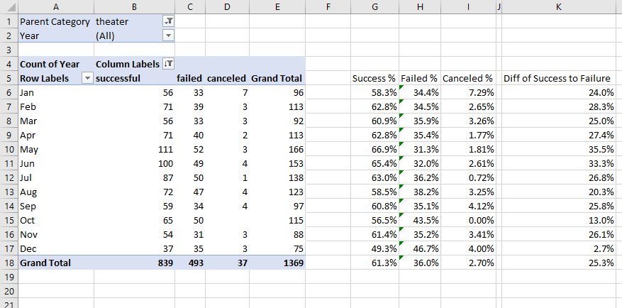

The second analysis was to determine the success vs failure rate of Kickstarers for the plays subcategory based on their goal amounts. Goals were set in buckets generally based on $5k increments except for the smallest two buckets and the last bucket. By taking the percentage of Success, Failed, and Canceled for each goal bucket, a line graph was created to show the varying percentages of success and failure by goal amounts.

Some limitations and challenges of the dataset would be the sample size of the data gets smaller as the goal bucket increases. The $25k+ goal amount has a total of 42 fundraisers while the goal amounts less than $25k have 1005 fundraisers. A possible challenge would be the use of percentages in a line graph to display the data instead of a bar graph with the number of successful, failed, and canceled fundraisers. The line graph does not factor in the total projects in each bucket

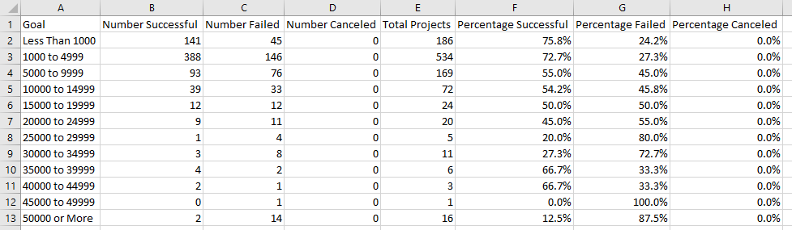

Results

Two conclusions to draw from the Theater Outcomes by Launch Date is May and June are the 2 months that have the highest percentage of success along with the most Kickstarters launched. The December has the least total number of successful fundraisers along with having the least number of fundraisers started.

The analysis can conclude the $1k - $4,999 bucket is the most popular Goal bucket for fundraisers. Looking at the goal amounts from $0 - $29,999, there is a steady decline in successful fundraisers until the dataset has much smaller

The results for the Outcomes based on Goals can be better displayed as a bar graph to show the how many total projects there are per goal range.